AI361-LAB1

Name: Youssef Mostafa Mohamed ElNahas

ID: 4311779

Task 1 – Exercise 1 (**CHANGING PIXEL VALUES**):

Loading another copy using iio.imread()

Changing the required values to change from 8 to 5

Then simply printing it and plotting it

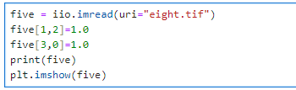

### Task 2 – Exercise 2 (**HINKING ABOUT RGBA COLOURS):**

Allowing the input from the user in the first three lines and saving each in a variable. (input and output path, and the desired change level) which was required in the lab

Loading the image from the input path provided using iio.imread() to be able to access the image itself

For loop on each value from 0 till the number of rows (The Length), inside the for loop is another for loop on each value from 0 till the number of columns (The Width), The nested loop is needed to go through each pixel of the image to modify it

Changing each pixel value’s channel to the required level which was previously taken from user

Then showing the Image post-modification in the console using plt.imshow()

Then finally saving the edited image to the desired output path iio.imwrite()



 